Limit Laws

Addition law: **The limit of the sum is the sum of the limits**

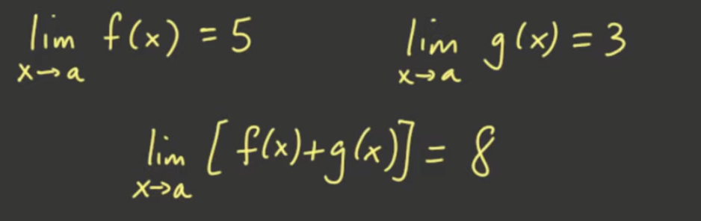

Justification:

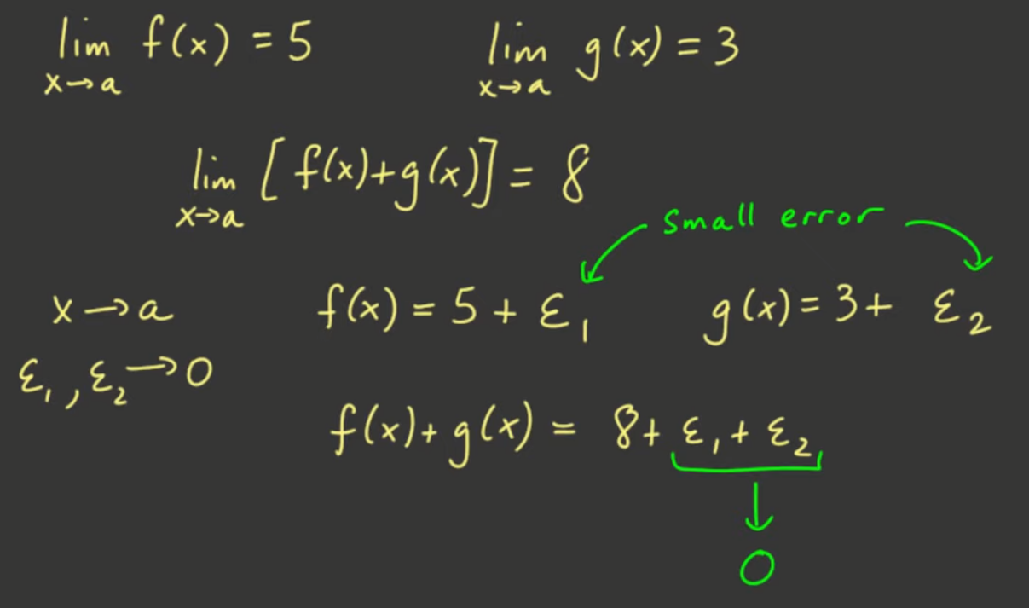

General statement:

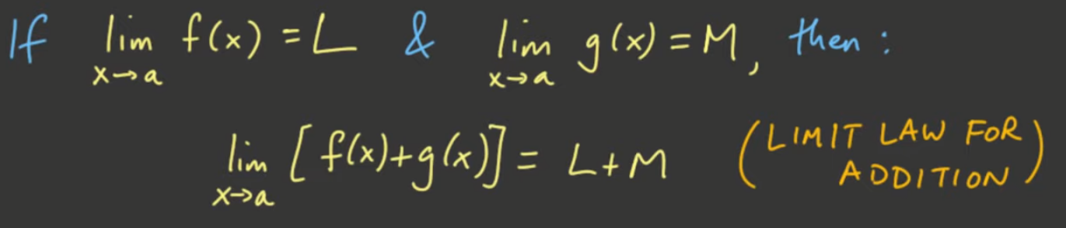

* also works for one-sided limits
  + Just make sure that you are coming from the SAME side of the limits

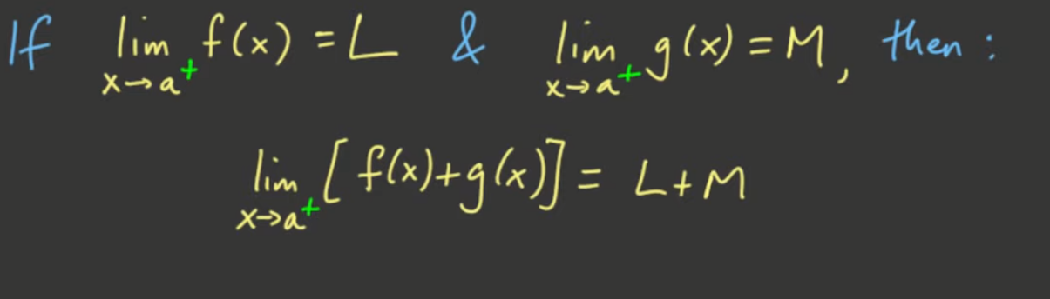

Subtraction Law (same as addition)

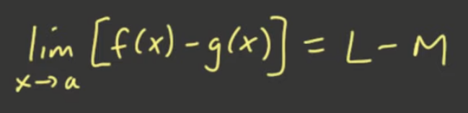

Multiplication Law (same as addition)



Division Law

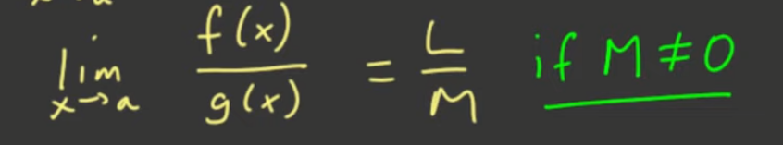

* If M = 0, we will see it in the other sections of the lectures

Summary:

